WIDA ACCESS test – Speaking Rubric – Student Version
Fourth & Fifth grade | “Discourse Level”  (“How do I talk?) | “Sentence Level” | “Word/Phrase Level”
 | Linguistic Complexity | Language Forms | Vocabulary Usage
Level 6  Reaching | ** speaks clearly & with confidence all or most of the time –few or no pauses  ** speaks in a way that makes sense for the situation (“fancy” talk / “friend” talk) | **uses lots of different sentence patterns / kinds of sentences to show meaning (many short & long sentences) | ** uses “just right” words for what is seen in the picture all or most of the time
Level 5  Bridging | ** speaks clearly & with confidence some of the time – few short pauses  ** speaks in a way that makes sense for the situation (“fancy” talk / “friend” talk) | **uses some different sentence patterns / kinds of sentences to show meaning (some short & long sentences) | **uses “just right” words for what is seen in the picture some of the time
Level 4  Expanding | ** speaks clearly & with confidence some of the time –some longer pauses/mistakes, but easy to understand meaning  ** speaks in a way that makes sense for the situation (“fancy” talk / “friend” talk) | **uses a few different sentence patterns / kinds of sentences to show meaning (a few short & long sentences) | **uses “just right” words for what is seen in the picture a little – sometimes cannot find the right word
Level 3  Developing | ** speaks clearly & with confidence sometimes –longer pauses/ mistakes, a little hard to understand meaning | **Tries to use different sentence patterns / kinds of sentences to show meaning (a few short & long sentences) –some repeats / mistakes | **uses “just right” words for what is seen in the picture a little – has trouble finding the right science/social studies/ math words
Level 2  Emerging | ** only speaks clearly & with confidence a little –longer pauses/ mistakes, hard to understand meaning | **”chunks of words” / uses the same kind of sentence again and again / repeats | **Tries to use “just right” words for what is seen in the picture uses few science/social studies/ math words
Level 1  Entering | ** can’t speak clearly & with confidence –long pauses/ many mistakes,very hard to understand meaning | 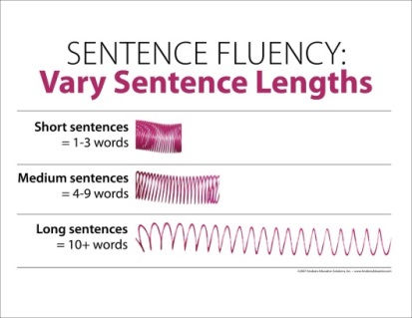  **”chunks of words” / uses the same kind of sentence again and again / repeats | **uses only very easy words
WIDA ACCESS test – Speaking Rubric – Student Version
Third grade | “Discourse Level”  (“How do I talk?) | “Sentence Level” | “Word/Phrase Level”
 | Linguistic Complexity | Language Forms | Vocabulary Usage
Level 6  Reaching | - Speaks very clearly  - Very confident  - Very few/no pauses  - Lots of “fancy talk” | ** MANY short and long sentences! | ** uses “just right” words ALL or MOST of the time!
Level 5  Bridging | - Speaks clearly  - Confident  - Few short pauses  - Some “fancy talk” | ** SOME short and long sentences! | **uses “just right” words SOME of the time
Level 4  Expanding | - Speaks pretty clearly  - Some confidence  - Some pauses, but easy to understand  - A little “fancy talk” | ** A FEW short and long sentences! | **uses “just right” words A LITTLE – sometimes can’t find the right word
Level 3  Developing | - Speaks fairly clearly  - A little confidence  - Some longer pauses  - Hard to understand sometimes  - Little or no “fancy talk” | ** A FEW short and long sentences! Some repeats/mistakes | **uses “just right” words A LITTLE – has trouble finding the right science/social studies/ math words
Level 2  Emerging | - Sometimes unclear  - Some “guessing”  - Longer pauses  - Hard to understand often  - Uses “friend talk” | **”chunks of words” / uses the same kind of sentence again and again / repeats | **Tries to use “just right” words-- uses few science/social studies/ math words
Level 1  Entering | - Unclear  - “guessing”  - Long pauses  - Very hard to understand  - Uses only “friend talk” | 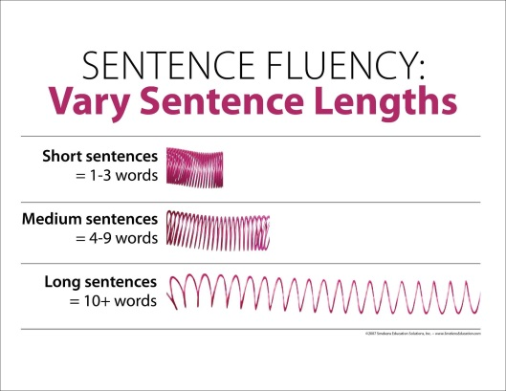  **”chunks of words” / Many repeats / copies | **uses only very easy words

WIDA ACCESS test – Speaking Rubric – Student Version
First & Second grade | “Discourse Level”  (“How do I talk?) | “Sentence Level” | “Word/Phrase Level”
 | Linguistic Complexity | Language Forms | Vocabulary Usage
Level 6  Reaching | - Very clear  - Few / no pauses    - Lots of “fancy talk” | ** MANY short and long sentences!  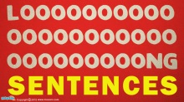 | ** uses “just right” words ALL or MOST of the time!
Level 5  Bridging | - Clear  - Few short pauses  - Some “fancy talk” | ** SOME short and long sentences! | **uses “just right” words SOME of the time
Level 4  Expanding | - Pretty clear  - Some pauses, but easy to understand  - A little “fancy talk” | ** A FEW short and long sentences! | **Sometimes can’t find just the right word
Level 3  Developing | - Fairly clear  - Some longer pauses  - Hard to understand sometimes  - Little or no “fancy talk” | ** Some repeats/mistakes | **Has trouble finding the right science/social studies/ math words
Level 2  Emerging | - Sometimes unclear  - Some “guessing”  - Longer pauses  - Hard to understand  - Uses mostly “friend talk” | **”chunks of words” / repeats and mistakes | **uses few science/social studies/ math words
Level 1    Entering | - Unclear  - “guessing”  - Long pauses  - Very hard to understand    - Uses only “friend talk” | 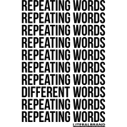  **”chunks of words” / MANY repeats / COPIES | **uses only very easy words

